**Cuizine:**

**Home**/Cuizine

Biryani

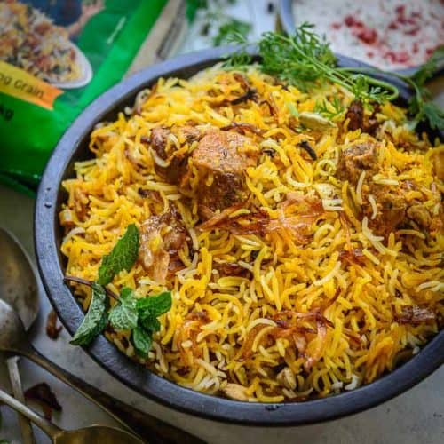

**Biryani** , also known as **biriyani**, **biriani**, **birani** or **briyani**, is a mixed rice dish that originates from the Hindu of the Indian subcontinent. This dish is especially popular throughout the Indian subcontinent, as well as among the diaspora from the region. It is also prepared in other regions such as Iraqi Kurdistan. It is made with Indian spices, rice, meat (chicken, goat, beef, prawn, or fish), vegetables or eggs. *Biryani* is a Hindustani word derived from the Persian language, which was used as an official language in different parts of medieval India by various Islamic dynasties. One theory states that it originated from *birinj*, the Persian word for rice. Another theory states that it is derived from *biryan* or *beriyan*, which means "to fry" or "to roast.

Haleem

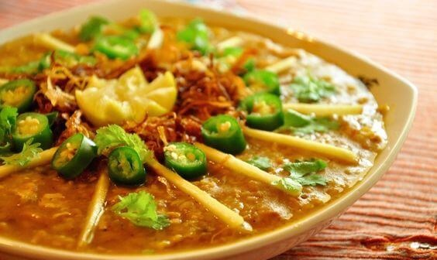

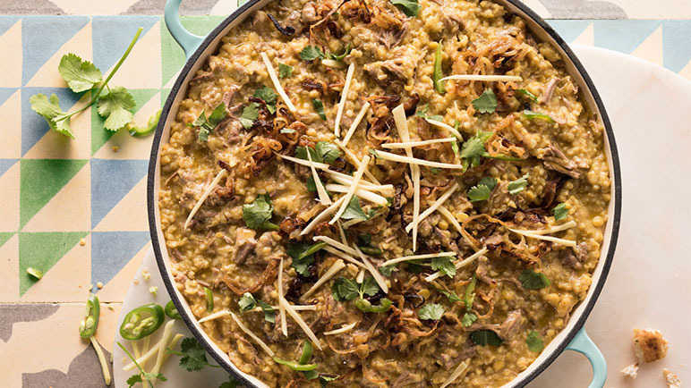

**Haleem** is a stew popular in the Middle East, Central Asia, and the Indian subcontinent. Although the dish varies from region to region, it always includes wheat or barley, and sometimes meat and/or lentils. Popular variations include keşkek in Turkey, Iran, Afghanistan, Tajikistan, Uzbekistan, Azerbaijan and northern Iraq; Hareesa in the Arab world and Armenia; Halim in Bangladesh and West Bengal; Khichra in Pakistan and India. Americans also have a similar dish called Farina. Haleem is made of wheat, barley, meat (usually minced beef or mutton (goat meat or Lamb and mutton) or chicken), lentils and spices, sometimes rice is also used.

Nihari

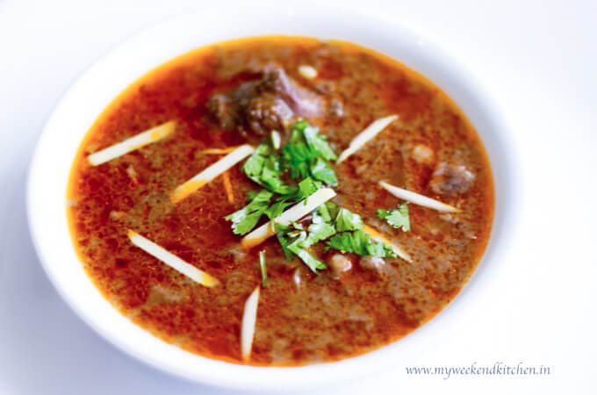

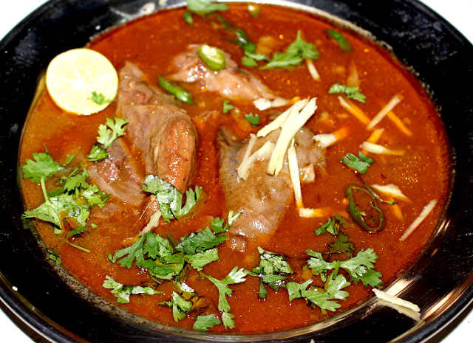

**Nihari** is a stew from the Indian subcontinent consisting of slow-cooked meat mainly shank meat of beef or lamb and mutton, goat meat and chicken, along with bone marrow. Nihari developed with the overall cuisine of Muslims of the Indian subcontinent. It has been an old popular delicacy in parts of Bangladesh, particularly Dhaka and Chittagong. People cooked it for one whole night and they got it in the early morning at sunrise. It is a popular dish and is regarded as the national dish of Pakistan.

Chicken Karahi

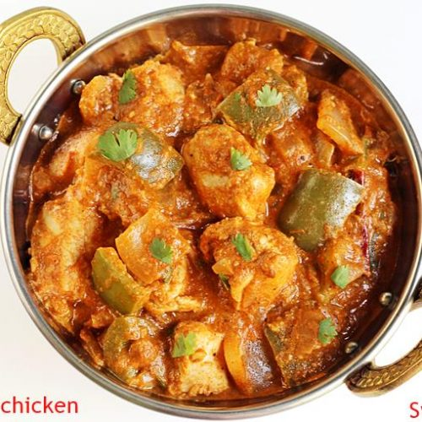

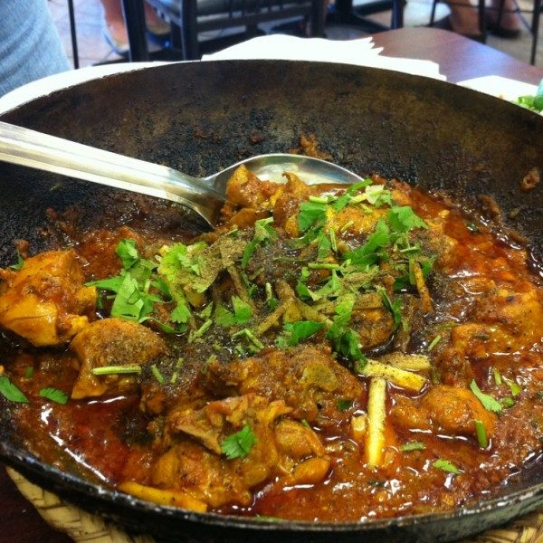

**Chicken karahi**, also known as **gosht karahi** (when prepared with goat or lamb meat instead of chicken), and **kadai chicken**, is a dish from the Indian subcontinent noted for its spicy taste; it is notable in Pakistani and North Indian cuisine. The Pakistani version does not have capsicum or onions whereas the North Indian version uses capsicum. The dish is prepared in a karahi (wok). It can take between 30 and 50 minutes to prepare and cook the dish and can be stored for later consumption. It can be served with naan, roti or rice. This dish is one of the hallmarks of Indian and Pakistani cuisine.

Kheer

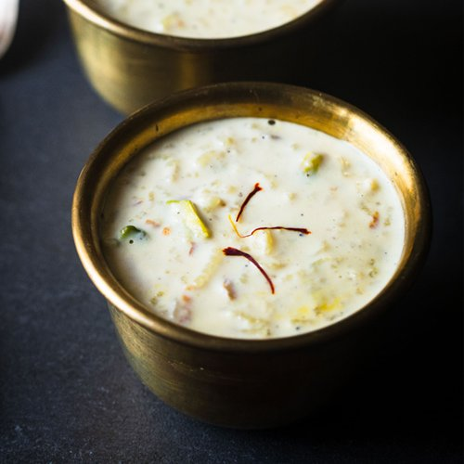

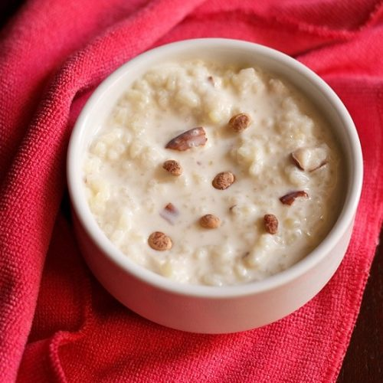

**Kheer** is a rice pudding, originating from the Indian subcontinent, made by boiling with milk and sugar one of the following: rice, broken wheat, tapioca, vermicelli, sweet corn, etc. It is flavoured with cardamom, raisins, saffron, cashews, pistachios, almonds or other dry fruits and nuts. It is typically served during a meal or as a dessert. It is also known in some regions as **meetha bhaat**, **payasam**, **payasa**, and **phirni.** Kheer is prepared in festivals, temples, and all special occasions. The term *kheer* (used in North India) may derive from the Sanskrit word *Ksheera* (which means "milk").

Falooda

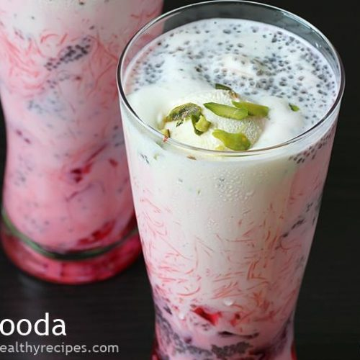



**Falooda** (also **Faluda, Faloodah**) is a cold dessert with origins in the Indian subcontinent. Traditionally it is made from mixing rose syrup, vermicelli, sweet basil (**sabza/takmaria**) seeds with milk, often served with ice cream. The vermicelli used for preparing falooda is made from wheat, arrowroot, cornstarch, or sago. Falooda is not only a drink but can be a meal in itself. Some ingredients like soaked basil seeds have a cooling effect on the body. Falooda is also often served with various nuts.